Information for attending a Wrekin Forest School Birthday Party

- Getting there…The nearest postcode is TF6 6E, we are about half a mile from the cottages, but on the same road…look out for our two big flags at the end of our gravel driveway. DO NOT CALL IN AT THE COTTAGES!!!
- https://wrekinforestschool.co.uk/visit
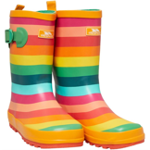
- What to wear…..no matter the time of year please have old clothes, wellies and if you have them, waterproofs.
- What else will you need?.....we will provide you with drinks and marshmallows at all our parties. Some, but not all, of our parties give you food too.
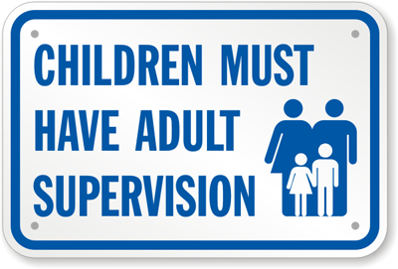
- Expectations……we expect parents of children six years or less to stay, be responsible for and supervise their children. We anticipate that we will supervise your seven year old children and those who are older.

